Categories of Taxation

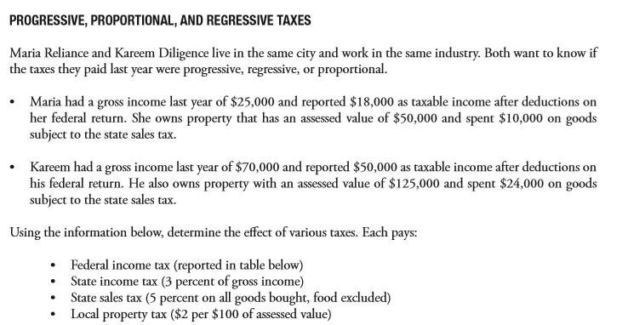

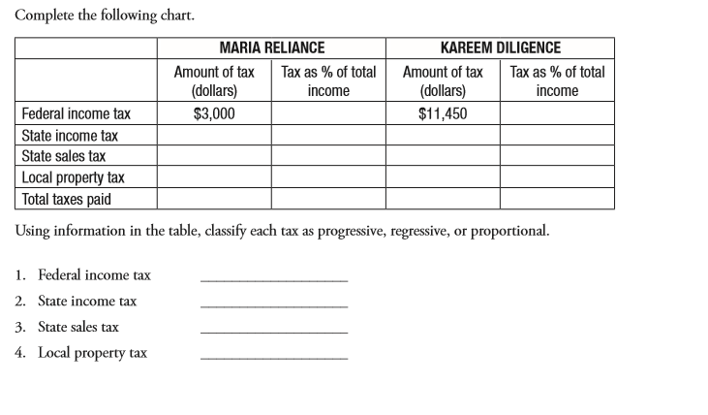

Progressive

Proportional

Regressive

Regressive

$3000 16.6% $11,450 22.9%

$750 3% $2,100 3%

$500 2.7% $1,200 2.4%

$1000 5.5% $2,500 5%

$5,250 21% $17.250 24.6%

$16 f